Table of Contents
1 Overview 2
2 Business Application Leaver Scheme 2
3 Remove Access Exceptions 2
4 Manager Notification 3
5 Leaver Process 3
6 Leave of Absence Process 4
7 Long Term Disability Process 5
8 Inactive Work Item Escalation Rule 6
9 Leaver Identity Trigger Correlation Population 6
10 Leaver Process Priority 6
11 Postpone Account Delete By X Days 6
12 Move Account On Termination 7
13 Population Based Leaver Option 7
14 Leaver Persona 7
15 Hide Leaver IdentityIQ Email Content 7
16 Notify Operations LOA 8
17 Notify Operations LTD 8

Document Revision History
Version | Date | Status | Author | Summary of Changes
Version 1 | 3/2/18 |  | Rohit Gupta
Version 2 | 4/4/18 |  | Cathy Mallet | Minor grammar/spelling/etc edit

Overview
The purpose of this document is to explain the technical details of the Leaver Feature that is bundled with the Accelerator Pack. These feature options are configured via the Self Service Onboarding Wizard or the IdentityIQ Administrative Wizard. The Administrative Wizard can define “Extended Rule” and Java Regular Expression Options.

Business Application Leaver Scheme
This is a simple true or false value attribute on an application named “Is Business Application”. During the leaver process, the Business Application leaver options supersede the Infrastructure/Technology application for RBAC Business Role access removal.

Remove Access Exceptions
During the leaver process, some access can be excluded from removal. This option can be enabled on an application using an attribute named “Remove Entitlement Exceptions Identification”. The internal name of this attribute that is defined on an application is “removeEntitlementLeaverExceptionExpression”. This attribute supports two formats:

- String Format with Operation
- String Format with Java Regular Expressions

Example of String Format with Operation “[Schema Attribute Name]#IIQEntitlementLeaverException#[Schema Attribute Value]#IIQEntitlementLeaverException#[Operation]”. This format is automatically set from the Self Service Onboarding Wizard.

String Tokens and Separators | Description
[Schema Attribute Name] | Application Schema Attribute Name
#IIQEntitlementLeaverException# (Token Separator) | Token to Separate Identity Schema Attribute Name and Schema Attribute Value
[Schema Attribute Value] | Application Schema Attribute Value
#IIQEntitlementLeaverException# (Token Separator) | Token to Separate Schema Attribute Value and Operation
[Operation] | STARTSWITH  ENDSWITH  CONTAINS  EQUALS

Example of String Format with Java Regular Expression “[Schema Attribute Name]#IIQEntitlementLeaverException#[Java Regular Expression]”.

String Tokens and Separators | Description
[Schema Attribute Name] | Application Schema Attribute Name
#IIQEntitlementLeaverException# (Token Separator) | Token to Separate Application Schema Attribute Name and Java Regular Expression
[Java Regular Expression] | This is executed against [Schema Attribute Name] value. “IdentityEntitlement” objects are excluded on match.

Manager Notification
Manager Notification is sent out to the sponsor of the contractors or to the manager of employees during Leaver Lifecycle Event. Sponsor on contractor is detected using extended attribute "ctrMgr".

Notification can be cce’d to any workgroup using Global Definition “CC Email To Workgroup” configuration. If there is a requirement to cc email to different workgroups as per population, an extended rule can be used and referenced using Global Definition configuration “CC Email Rule” option.

Leaver Process
This process starts with an event which can be configured using the “Configure Triggers” QuickLink. It is based on the Identity Cube’s old and new attribute values or leaver date. This event kicks off the Leaver Workflow.

The same process can be kicked off manually by Operations Quick Link “Terminate Identity Access”. This QuickLink is accessible to the “Operations” workgroup.

This workflow builds a provisioning plan based on existing accounts on an Identity. Here is the pseudo algorithm:
.
- Build a Provisioning Plan for existing accounts on an Identity based on the Application’s Leaver Options
  - If the option is “Extended Rule”,execute rule and merge the Account Request into the Provisioning Plan
- Exclude any Identity Entitlement from removal that matches with Java Regular Expression or String Format Operation Comparison. See Remove Access Exceptions
- Defer and Exclude Application’s Access Removal for X Days termination option
- Postpone Deletion of Application Account by X Days option
- Remove All Birthright and RBAC Roles either assigned automatically by assignment rule or requested manually. See Business Application Leaver Scheme

There are some additional processing steps that are performed by this workflow
- Take a Termination Snapshot of an IdentityIQ Cube for these events:
  - Manual event by the “Terminate Identity Access” QuickLink
  - Lifecycle Event
- Launch X Days Removal Task for X Days Termination Option
- Clear Authentication Questions and Answers
- Auto Reject Pending Access Request
- If the Move Account option is selected for termination option, do a target aggregation on the application
- Reassign IdentityIQ Artifacts and Work Items Ownership to either the manager or someone else based on reassignment rule
  - The “No Manager Found” Workgroup is used if no owner is found
- Reassign Business Approver ownership for applications, entitlements, and roles to either the manager or someone else based on reassignment rule
  - The “No Manager Found” Workgroup is used if no owner is found
- Reassign Service Account Owner to either the manager or someone else based on reassignment rule
  - The “No Service Account Owner” Workgroup is used if no owner is found
- Email is sent to new owner for Service Account ownership
- Email is sent to new owner for Business Approver ownership
- Email is sent to new owner for IdentityIQ Artifacts and Work Items

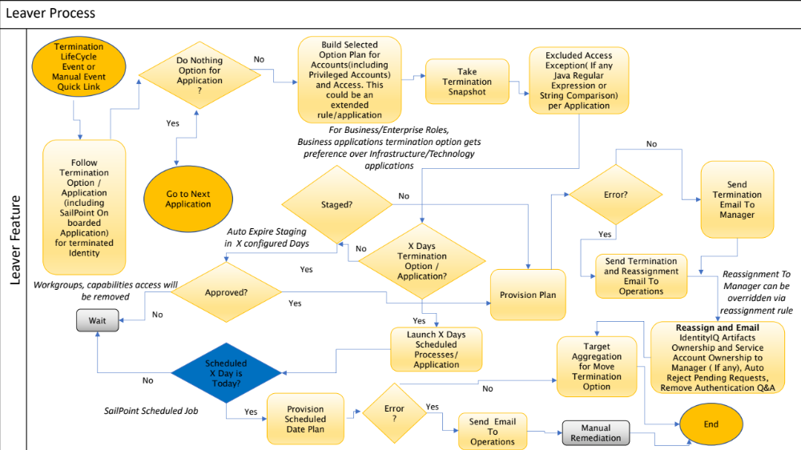

Leave of Absence Process
This process starts with an event which can be configured using the “Configure Triggers” QuickLink. It is based on the Identity Cube’s old and new attribute values or leave of absence date. This event kicks off the Leave of Absence Workflow.

The same process can be kicked off manually by the Operations QuickLink “Process Identity Event”. This Quick Link is accessible to the “Operations” workgroup.

This workflow builds a provisioning plan based on existing accounts on an Identity. Here is the pseudo algorithm:
- Build a Provisioning Plan for existing accounts on an Identity based on Application’s Leave of Absence Options
  - If the option is “Extended Rule”, execute the rule and merge the Account Request into the Provisioning Plan

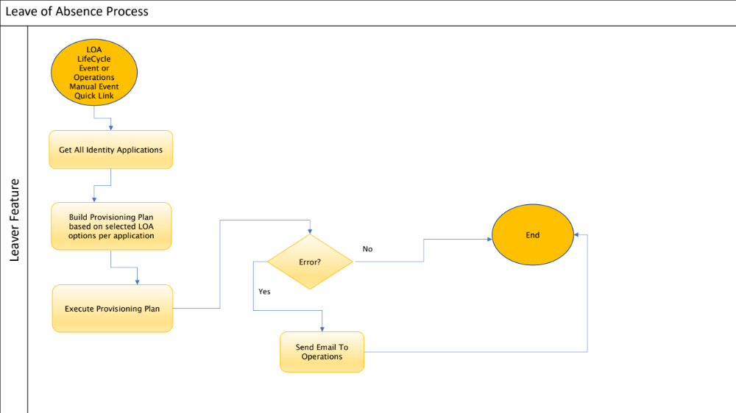

Long Term Disability Process
This process starts with an event which can be configured using the “Configure Triggers” QuickLink. It is based on the Identity Cube’s old and new attribute values or long-term disability date. This event kicks off the Long-Term Disability Workflow.

The same process can be kicked off manually by the Operations QuickLink “Process Identity Event”. This Quick Link is accessible to the “Operations” workgroup.

This workflow builds a provisioning plan based on existing accounts on an Identity. Here is the pseudo algorithm:
- Build a Provisioning Plan for existing accounts on an Identity based on the Application’s Long-Term Disability Options
  - If the option is “Extended Rule”, execute the rule and merge the Account Request into the Provisioning Plan
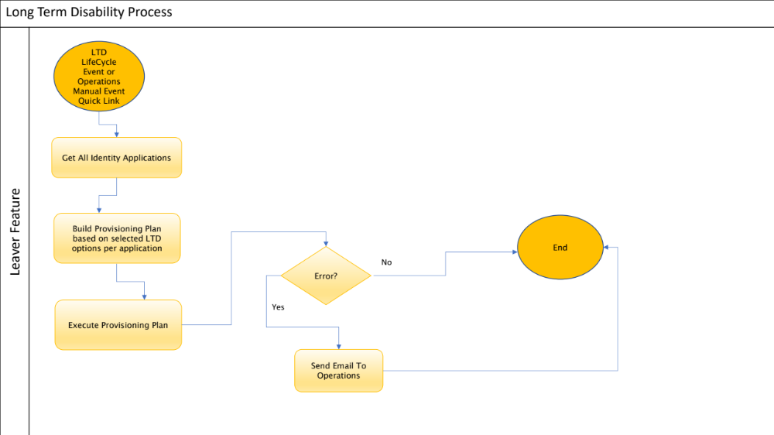

Inactive Work Item Escalation Rule
The rule “Rule-FrameworkInactiveWorkItemEscalation” is executed by Performance Maintenance
Task to escalate inactive owner Workitem to new owner. This rule reassignment can be controlled by QuickLink “Global Definition” to either reassign Workitem to manager or someone else using reassignment rule.
Here is the pseudo algorithm of the rule.
- Reassignment Rule gets preference over default manager assignment
- In case reassignment rule is not defined, manager is used
  - In case manager is not defined on Identity Cube “No Manager Found” workgroup is used
- In case manager reassignment is turned off and there is no reassignment rule
  - “No Reassignment” workgroup is used

Leaver Identity Trigger Correlation Population
By default, Accelerator Pack “LEAVER FEATURE” Lifecycle Event is configured only for correlated identities. Sometimes authoritative sources do not provide the terminated identities or delete them from the system. As a result, these identities during aggregation becomes uncorrelated in IdentityIQ and Leaver process does not kick off. For such cases, population “Accelerator Pack Correlated Identities” can be removed from “LEAVER FEATURE” Lifecycle Event.

Leaver Process Priority
If an Identity is eligible for Attribute Synchronization and/or Mover Process, Leaver Process gets priority over Attribute Synchronization and Mover.

Postpone Account Delete By X Days
This option is used to clean up accounts from an application after X number of days of an Identity’s termination.

Move Account On Termination
Multiple OU’s (Organizational Units) can be defined per application using Self Service Onboarding Wizard. Identity’s native id on the application is used and compared with this multiple OU list to get right OU for termination.

Population Based Leaver Option
Leaver Options can be defined per population on an application. This can be configured on an application from the Debug Page. These options get priority over Leaver options that can be defined on an application using Self Service Onboarding Wizard. Multiple populations can be defined for Leaver process. In case leaver identity matches multiple population, first matched population options will be used for Leaver. Here is an example of population options.
<entry key=“apPopulationLeaverOptions”>
<value>
<List>
<Map>
<entry key=“apPopulation” value=“Population 1”/>
<entry key=“apDeferAccountXDays” value=“40”/>
<entry key=“apRemoveAccessXDays” value=“10”/>
<entry key=“apTerminationOption” value=“Disable Only After X Days”/>
<entry key=“apTerminationExtendedRule” value=“”/>
</Map>

<Map>
<entry key=“apPopulation” value=“Population 2”/>
<entry key=“apDeferAccountXDays” value=“”/>
<entry key=“apRemoveAccessXDays” value=“”/>
<entry key=“apTerminationOption” value=“Disable Only”/>
<entry key=“apTerminationExtendedRule” value=“”/>
</Map>
</List>
</value>
</entry>

Leaver Persona
Leaver process gets kicked off only when all personas are dropped from an Identity. When persona feature is enabled, triggers defined based on authoritative sources are not used for Leaver process. Drop of personas are calculated based on Identity’s “relationships” attribute. Sample rule “Rule-Framework-IdentityAttribute-Relationships” packaged with Accelerator Pack must be used as a reference to define personas on an identity. Here is an example of dropped personas of an identity. Either keyword [INACTIVE] and deletion of persona on “relationships” attribute is considered as dropped persona.

Identity Relationships
EMPLOYEE [INACTIVE] (FTE1)
EMPLOYEE [INACTIVE] (FTE2)
STUDENT [INACTIVE] (100-Health Science-RIT)

Hide Leaver IdentityIQ Email Content
Leaver Email to Manager can be configured using Global Definitions option “Disable Static Email Content on Manager Emails“ to hide IdentityIQ specific content.

Notify Operations LOA
By Default, LOA Email is sent out to Operations on provisioning failures only. A Global Definition Configuration "Notify Operations on LOA for an Identity" can be used to send out email to Operations on LOA provisioning action.

In case, there is a requirement to cc this email, an extended rule can be used and referenced using Global Definition configuration “CC Email Rule” option.

Notify Operations LTD
By Default, LTD Email is sent out to Operations on provisioning failures only. A Global Definition Configuration "Notify Operations on LTD for an Identity" can be used to send out email to Operations on LTD provisioning action.

In case, there is a requirement to cc this email, an extended rule can be used and referenced using Global Definition configuration “CC Email Rule” option.

